Literacy support worksheet

8.1 There are different ways of reproducing

Pages 140–141 and 211

Reproduction

Asexual reproduction

1 What is asexual reproduction?

2 What is sexual reproduction?

3 What kind of DNA do the offspring have in asexual reproduction?

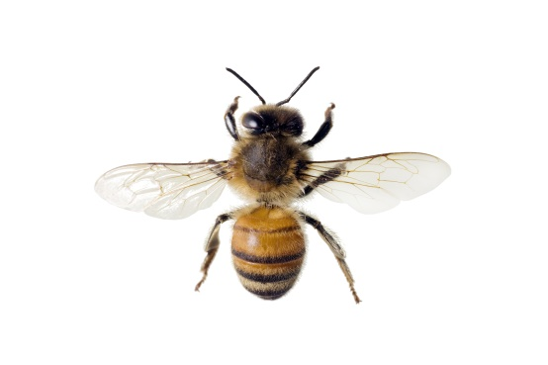

4 Describe one advantage and one disadvantage of asexual reproduction and a lack of variation:

a Advantage:

b Disadvantage:

5 Why does the queen bee like parthogenesis?

6 List three structures that use vegetative reproduction:

7 Draw an example of vegetative reproduction below:

Sexual reproduction

8 What two cells were needed to join, in order to make you?

9 What does sexual reproduction produce?

10 Why is variation within a population important?

11 What is the difference between identical and non-identical twins in terms of their DNA?

Hermaphrodites

12 What is a hermaphrodite?

13 Some organisms that are hermaphrodites can ‘turn off’ one sexual system. When and why would this be helpful? Use Figure 8.7 in *Oxford Science 8 Western Australian Curriculum* to help you.

Word detective

14 True or false

Read each of the statements below and circle whether it is true or false.

a Binary fission is when an organism splits in half. T or F

b Parthenogenesis involves fertilised eggs splitting into new organisms. T or F

c Fragmentation is the same as binary fission. T or F

d Fragmentation in plants is referred to as vegetative reproduction. T or F

e Eggs fuse to make new organisms. T or F

f Hermaphrodites have female and male reproductive systems. T or F

Literacy support worksheet

8.2 The female reproductive system produces eggs in the ovaries

Pages 142–143

Female reproduction

1 Label the following diagram of the human female reproductive system.

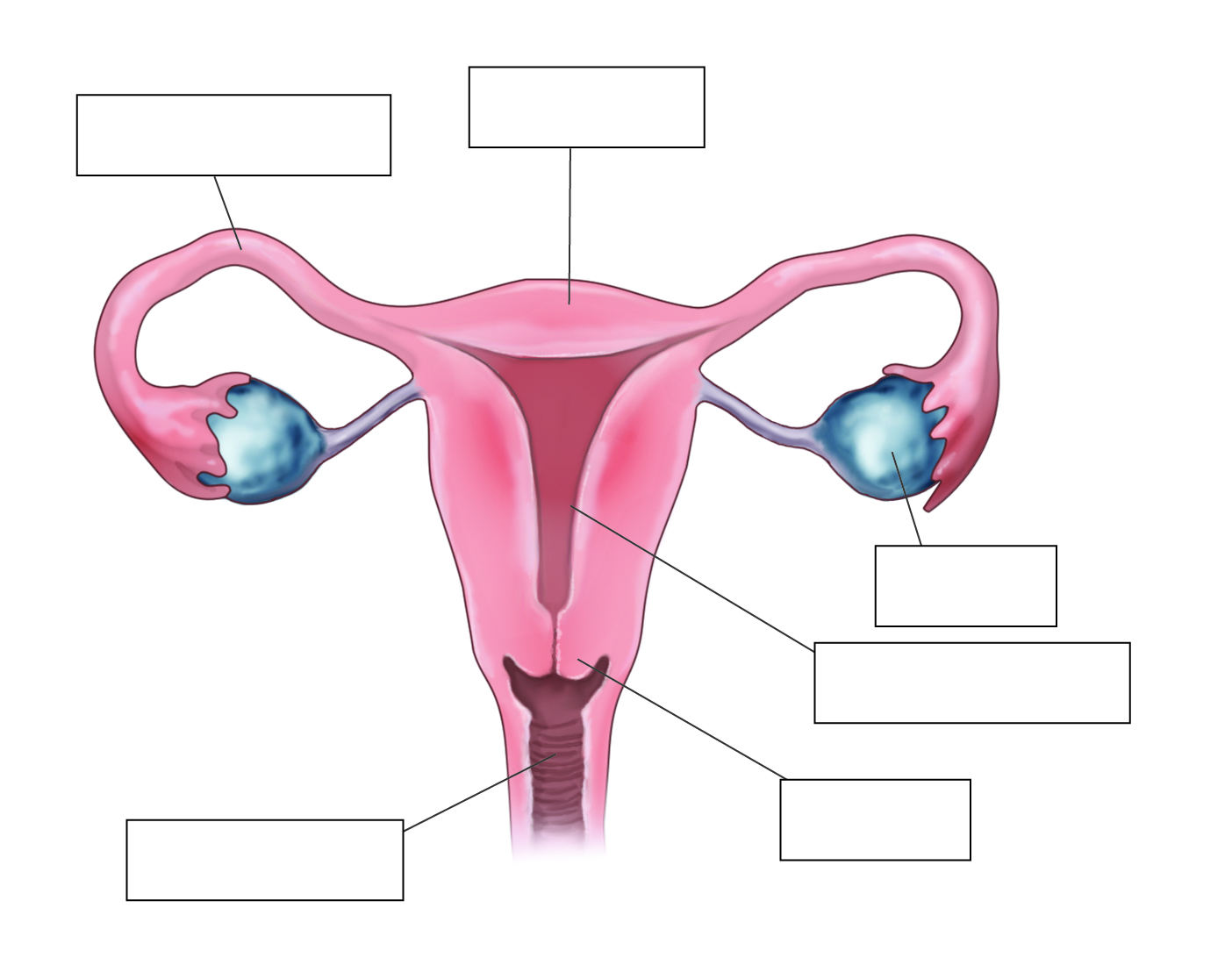

2 Draw a line to match each organ on the left to its function, in the column on the right.

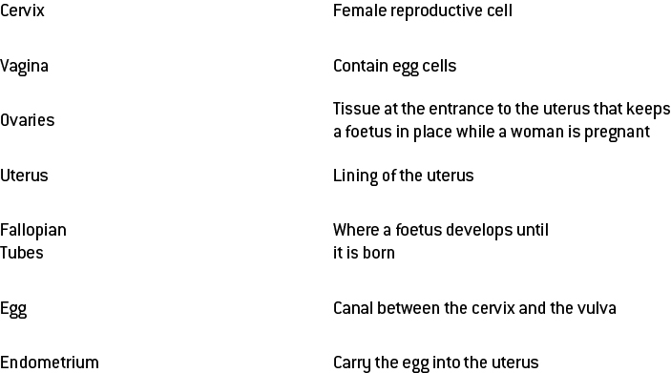

3 What is ovulation?

4 What is the average age that females first get their period?

5 On average, how long do menstrual periods last?

6 Use Figure 8.10 in *Oxford Science 8 Western Australian Curriculum* to help you fill in the diagram of the menstrual cycle:

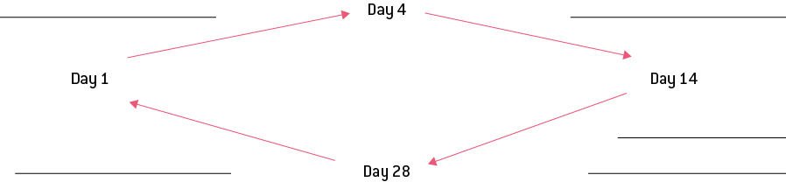

Word detective

7 True or false

Read each of the statements regarding giving birth, and circle whether it is true or false.

a The delivery of the placenta is one of the stages of birth. T or F

b The umbilical cord attaches the placenta to the mother. T or F

c The cervix must open 12 cm before a baby’s head can move through the vagina. T or F

d A baby is still attached to the placenta when born. T or F

e The first stage of birth involves the walls of the placenta contracting. T or F

f Belly buttons are formed from the umbilical cord. T or F

g Human mothers go through five stages of childbirth. T or F

Literacy support worksheet

8.3 The male reproductive system produces sperm in the testes

Pages 144–145

Male reproduction

1 What is the difference between internal and external fertilisation?

2 Provide a brief sentence about what happens during fertilisation:

3 Where is sperm produced?

4 Why is the scrotum outside of the body?

5 Label the following diagram of the male reproductive system.

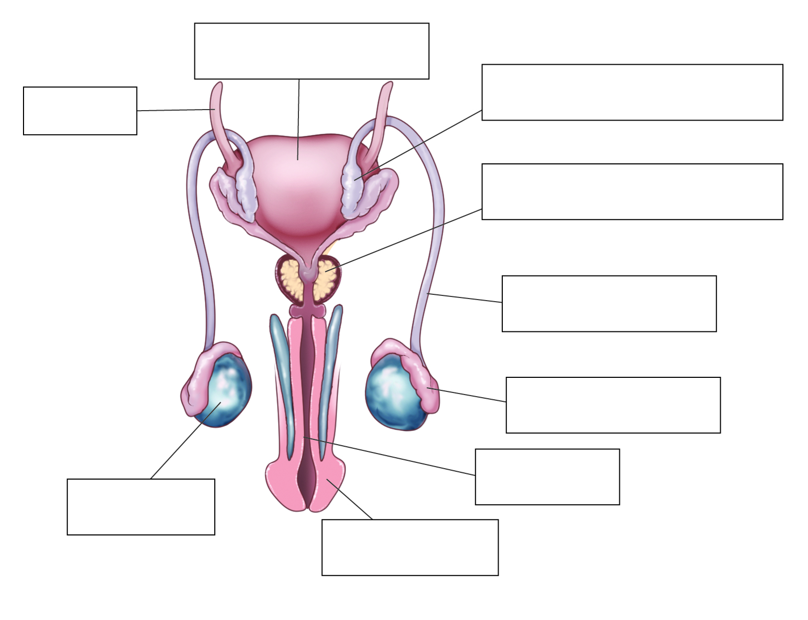

6 There are two monotremes in the world and both are located in Australia. What are these two animals?

7 What do birds, reptiles and monotremes have in common in their ability to reproduce?

8 In comparison to humans, name three differences in the way that amphibians and fish reproduce.

9 Complete the table below to compare human male and female reproduction (pages 140–145 of your student book).

|  |  |  |
| --- | --- | --- |
| Characteristic | Male | Female |
| What is the gamete called? |  |  |
| Main hormone |  |  |
| Name of gamete-producing organ |  |  |
| Tubes that provide a pathway for the gamete from where it was produced |  |  |

Word detective

10 Matching meaning

Draw a line to match the organ on the left to the description of its role on the right.

**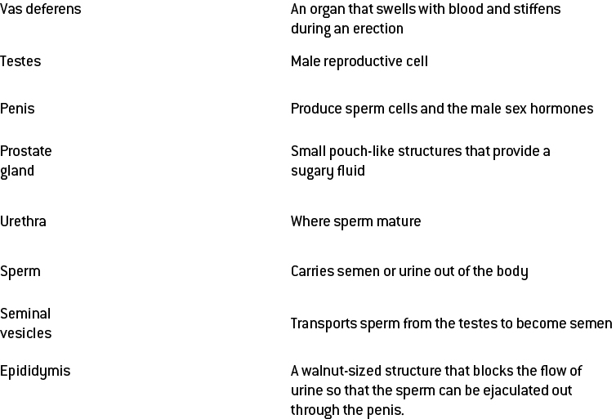**

Literacy support worksheet

8.4 Things sometimes go wrong in reproduction

Pages 146–147 and 211

Problems in the reproductive system

Endometriosis

1 What is the endometrium?

2 In which two places can endometriosis occur?

3 In which two ways is endometriosis like the menstrual cycle?

4 What are three effects of endometriosis?

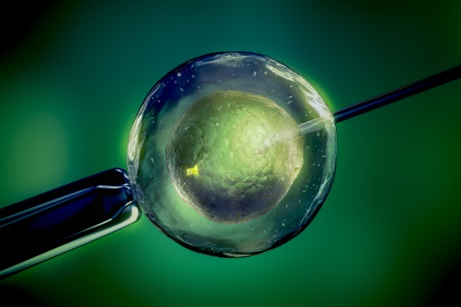Human reproduction

5 What is ART?

6 What is IVF? Explain the process.

7 What are three benefits of IVF?

8 What are the potential risks involved with screening tests?

Preserving biodiversity

9 List four reasons why it is important to stop species from becoming extinct

10 What is a captive breeding program?

Contraception and desexing

11 What does contraception do?

12 What are the benefits of contraception in captivity?

13 What is desexing?

Word detective

14 Mumbo jumbo

a Use the marked letters to find the secret word (e.g. olusntoi = solution).

b Unscramble each of the clue words below to find the message.

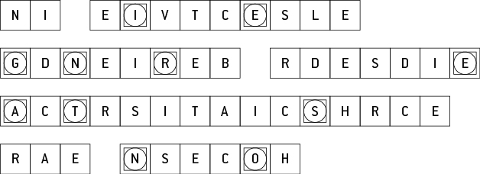

Secret word:

Message:

Literacy support worksheet

8.5 Plant sexual reproduction produces seeds

Pages 148–149 and 212

Plant sexual reproductive system

1 Label the reproductive organs of a flower on the diagram below.

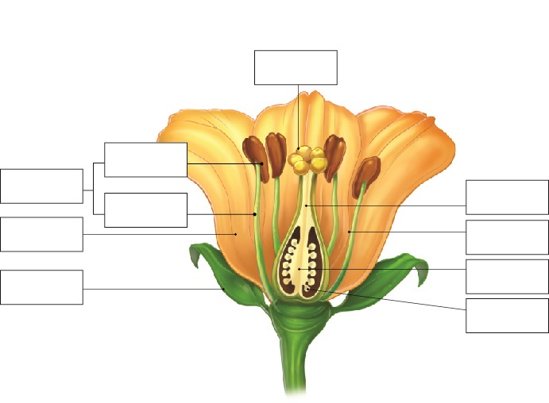

2 Match the organ in the reproductive system of a plant (on the left) with its function (on the right).

**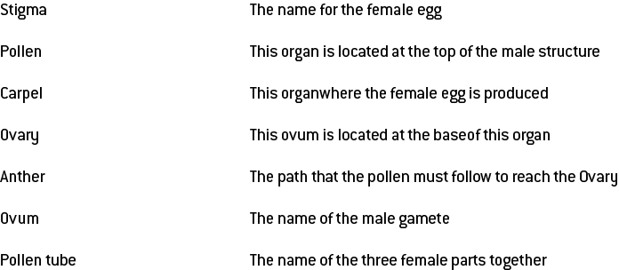**

3 Label the structure of the carpel below.

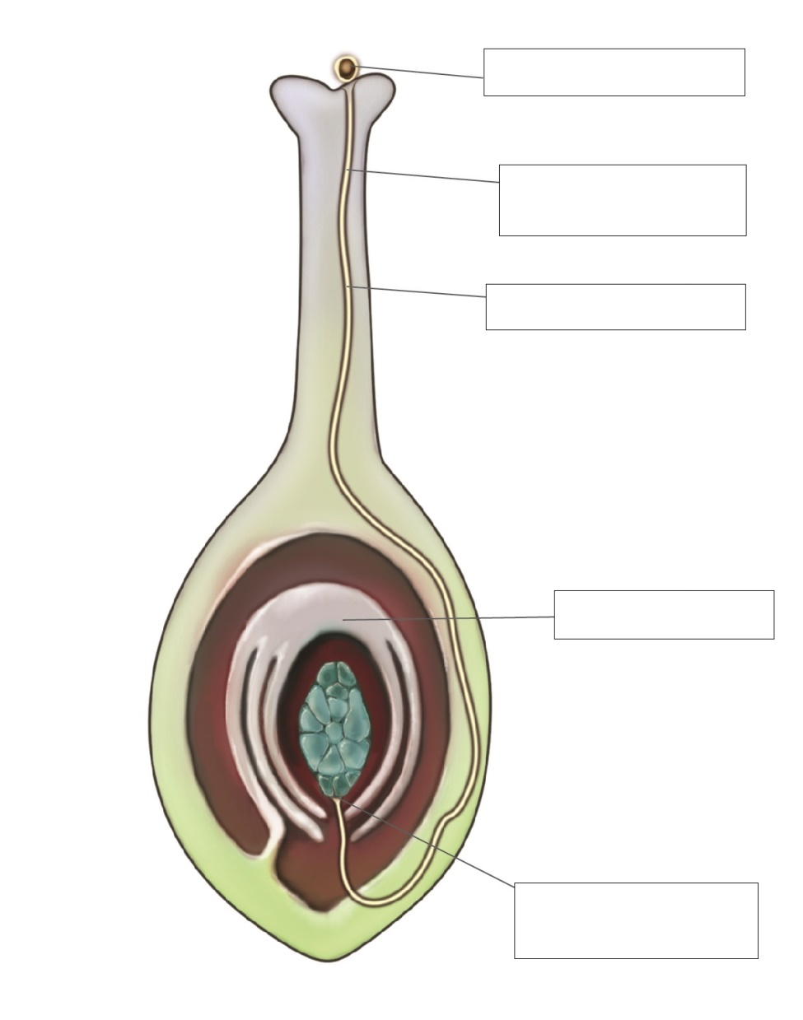

4 Name the three types of pollination.

5 What are spores?

6 Use the diagrams on p 149 of your student book to briefly explain how each plant reproduces and how it attracts animals.

|  |  |
| --- | --- |
| SW0809_00951-r  Rafflesia | How does it reproduce?      How does it attract animals? |
| SW0810_00951-r  Bottlebrush | How does it reproduce?      How does it attract animals? |
| SW0811_00951-r  Daffodil | How does it reproduce?      How does it attract animals? |

Word detective

7 Fill in the gaps

Fill the gaps in the sentences, using the words provided below.

self-pollination zygote

sizes cross-pollination

reproductive stigma

fertilisation flower

Flowers come in all shapes and \_\_\_\_\_\_\_\_\_\_\_\_\_\_\_\_\_\_\_\_\_\_\_. The purpose of a flower is not necessarily to

become sweet-smelling and beautiful but to contain the sexually \_\_\_\_\_\_\_\_\_\_\_\_\_\_\_\_\_\_\_\_\_\_\_ organs of the

plant and to help fertiliation to occur. \_\_\_\_\_\_\_\_\_\_\_\_\_\_\_\_\_\_\_\_\_\_\_ involves pollen from a flower landing on

its own \_\_\_\_\_\_\_\_\_\_\_\_\_\_\_\_\_\_\_\_\_\_\_ or that of another flower, on the same plant.

\_\_\_\_\_\_\_\_\_\_\_\_\_\_\_\_\_\_\_\_\_\_\_ occurs when pollen from another plant lands on the stigma of a

\_\_\_\_\_\_\_\_\_\_\_\_\_\_\_\_\_\_\_\_\_\_\_ on a different plant. After \_\_\_\_\_\_\_\_\_\_\_\_\_\_\_\_\_\_\_\_\_\_\_ the ovary swells to

become a fruit. The fruit provides nutrition for the \_\_\_\_\_\_\_\_\_\_\_\_\_\_\_\_\_\_\_\_\_\_\_ to grow within the seeds.

Literacy support worksheet

8.6 Reproduction techniques have an impact in agriculture

Pages 150–151

Selective breeding and its impacts

1 What is selective breeding?

2 What would be the benefits of breeding a cow that produces lots of milk with a healthy bull?

3 What are some of the desired characteristics that sperm banks are used for?

a in race horses:

b in dogs:

4 How does selective breeding occur in plants?

5 How does selective breeding put a population at risk of disease? Give an example.

6 Many Tasmanian devils are being wiped out due to cancerous tumours.

a How did this happen?

b What could happen if such a large number continue to die?

7 The great Irish Potato Famine occurred in the 1800s. What happened to the potatoes due to a lack of diversity?

8 What is inbreeding?

9 What is the result of inbreeding within a population?

Word detective

10 Crossword

Read the clues below and fill in the crossword with the answers.

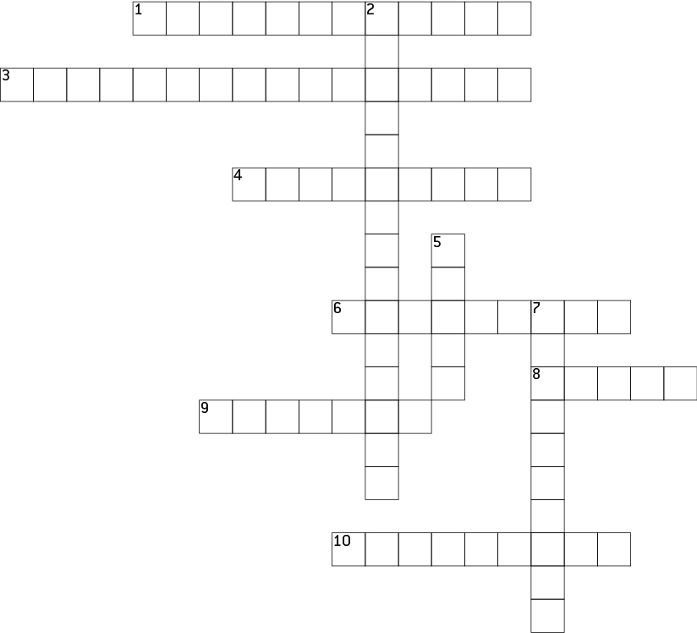

**Across**

1 The sort of technologies used to improve desired characteristics in plants and animals.

3 The name for selective breeding in plants

4 A type of breeding used to enhance offspring characteristics

6 Variety of genetic material

8 The name for reproduction in animals

9 Material that is passed through the genes, to the next generation

10 Another word for ‘babies’.

**Down**

2 Another word for ‘features’.

5 This type of bank is used for selective breeding in animals

7 The result of animals reproducing with animals they are closely related to.